SOW guidance for Azure Accelerate
AI Transformation Offer (ATO)
This document explains partner expectations for delivering Azure Accelerate ATO engagements and what should be reflected in Statement of Work (SOW).
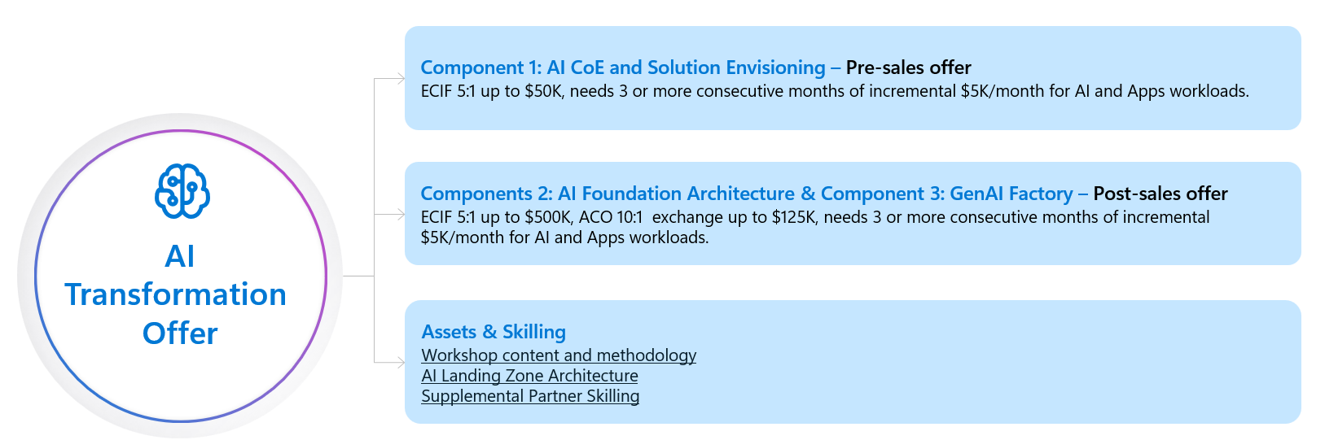
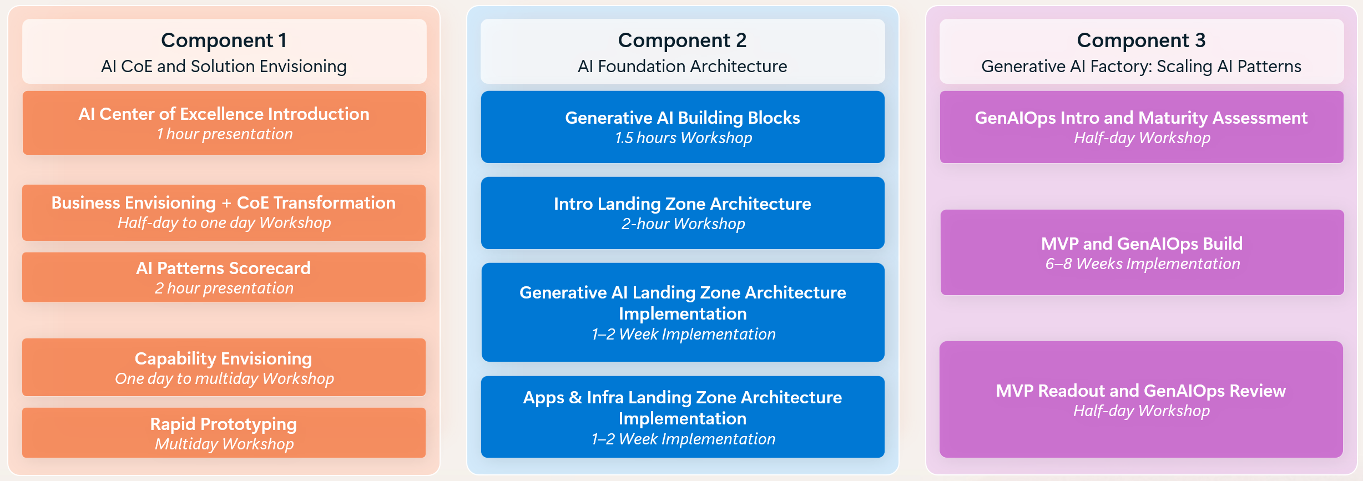

Terminology
* Proof of concept (PoC): tests if something can be built; often theoretical. Rapid prototyping goes further by showing how it’ll be built and validating readiness for production.
* Rapid prototyping: refers to an agile, time-boxed approach to quickly building and validating a solution concept—often in the form of a working prototype—before committing to full-scale development. Its purpose is to reduce technical and business risk, accelerate decision-making, and confirm feasibility against real requirements.
* Minimum viable product (MVP): a near-production deliverable for end users. Rapid prototypes are not production-ready, they are for validation and decision-making.

Customer qualification criteria for ATO
- The customer has a broad notion of their AI adoption (has more than 10 use cases)
- The customer has done one or more PoCs but not necessarily rapid prototyping
- Customer is classified in Microsoft taxonomy as Enterprise (Strategic, Upper Majors, Majors Growth) or managed SME&C.
- Customer must have a registered opportunity in MSX (Microsoft internal CRM) of at least $5K/month incremental ACR for Azure AI and Apps workloads. Partner must work with Microsoft account team to reflect customer opportunity in MSX properly.

Partner eligibility requirements
- Partner must have active enrollment in Azure AI Apps, AI Platform or Agentic DevOps Specialization.
- Since ATO is ECIF-based, partner must be an eligible ECIF supplier in the region where customer is based.
- Partner must be capable of delivering all three components of ATO. That applies to all requests, even if initial scope has only Component 1 or if partner engaged at Component 2/3 phase of the project. Leverage Partner Eligibility Checklist below to assess readiness and engage Microsoft PSA to address gaps. ATO delivery materials (presentations, workshop content, assessment docs etc.) are available here (partner must be registered in AI Specialized Partner community).

Funding Structure
As for all ECIF requests, partner must work with Microsoft account team to request funding. Requests for delivery of Component 1 (pre-sales) and Components 2&3 (post-sales) must be submitted separately.
Requests are submitted by Microsoft account teams through Azure Offer Navigator (Microsoft internal link).
Funding requests are subject to 5:1 ROI based on incremental ACR MSX (Microsoft internal CRM) and have at least $5K/month incremental ACR for Azure AI and Apps workloads specifically. Partner must work with Microsoft account team to reflect the opportunity size in MSX and ensure it is tagged with Azure AI and/or Azure App Platform workload tags.
There are two types of funding requests for ATO:
- Partner can request up to $50K pre-sales ECIF for delivery of ATO Component 1. After completion of Component 1 and established AI CoE on the customer side, partner may request funding for Components 2 and 3.
- Partner can request up to $500K post-sales ECIF for delivery of ATO Components 2 and 3 within one request. To proceed with this request, Component 1 must be delivered. If partner didn’t deliver Component 1 (e.g. it was delivered by Microsoft or by another partner), partner must assess customer readiness and ensure AI CoE is established.
Preferred scenario is when partner is engaged for delivery of Component 1 and plans to deliver all three components of ATO for the customer. Refer to milestone exit criteria for each component below.
ATO delivery materials (presentations, workshop content, assessment docs etc.) are available here. Partner must be registered in AI Specialized Partner community to access. AI Specialized partners must register in the community through this form.

Component 1: AI CoE and Solution Envisioning:

1.1: AI CoE Introduction and business envisioning (optional, though a CoE needs to be established):
- Learn how to transform your business by establishing an AI Center of Excellence (CoE) and develop an adoption strategy.
- Double click into the implementation of a CoE and leverage the Common Envisioning Framework for use cases prioritization mapping.
Milestone: The AI Center of Excellence (CoE) is established within the customer organization to drive a coordinated, sustainable AI transformation. This phase includes:
- Leadership alignment on the organization’s AI ambition, guiding principles, and strategic roadmap
- Identification and enablement of key roles and individuals responsible for executing the AI roadmap across business and technical domains
- Definition of operating and governance structures, including meeting cadence, decision-making bodies, and reporting mechanisms to ensure accountability and progress tracking.
The outcome is a fully operational AI CoE that provides clear ownership, alignment, and governance for AI initiatives across the organization.

Component 2: AI Foundation Architecture

2.1: Generative AI Building Blocks
- Outlines a 3-tier GenAI solution layers:
- Core (constant tech elements like security & monitoring).
- Variable (use case-specific components like app orchestrators).
- Solution-Dependent (elements like AI models & applications).

2.2: Intro to Landing Zone Architecture
- Establish a foundational architecture for CoE/AI Factory.
- Key Areas: Governance, networking & security, data foundation, and subscription management.
- Includes educational workshop and assessment of the client’s current estate.

2.3: AI Landing Zone Implementation using the Cloud Adoption Framework
- Delivered via architecture workshops, enabling hands-on setup of each desired landing zone component
- If a platform landing zone and/or an AI landing zone is already implemented, an assessment needs to be performed of this existing environment.
Milestone: AI-ready Azure Landing Zone for Development, Test, and Production environments are established, or existing Landing Zones are assessed and modified, to support AI workloads.

Component 3: Generative AI Factory

3.1: GenAIOps Intro and Maturity Assessment
- Define GenAIOps and assess the client’s current operations and technologies.
- Outcome: Determine maturity level and provide 5–6 actionable steps to advance.
- Identify 2–3 core priorities, from model selection to monitoring setup.

3.2: Proof of Value Selection & Development Timeline
- Select a prioritized, low-medium risk use case with medium-high return.
- Target delivery: 6–8 weeks, producing a production-ready solution.
- Align GenAIOps priorities with use case development to drive faster adoption

3.3: Full Cycle Development
- Deploy 2–3 GenAIOps priorities in dev and production environments.
- Complete the first proof of value solution, with options to iterate on a second.
- Establish a repeatable cycle to build a “factory-like” GenAIOps model.
Assumptions of existing environment:
- Leverages Azure Verified Modules (AVMs) for consistent deployment
- Realtime observability dashboards
- Configured alerts within Azure Monitor and Application Insights
- Monitoring with KPIs for AgentOps:
- Mean time to Detect
- Model Drift Detection Frequency
- Percentage of anomalies revolved without human intervention
Actions to take based on assumptions:
- Implement CI/CD pipelines
- Build observability dashboards
- Implement monitoring
- Focus on behavior, RAI, content safety and hallucinations.
Milestone: MVP deployed in customer’s environment and repeatable cycle to build a “factory-like” GenAIOps model established.

ATO Partner Readiness Checklist

CoE & Governance

AI Center of Excellence (CoE) Established
Has the partner got an offering to establish an AI CoE?
Does the offering also cover responsible AI?
Are operating and governance structures defined (meeting cadence, decision-making bodies, reporting mechanisms)?
Is there a clear process for use case prioritization (e.g., using the AI Discovery Cards)?
Is the CoE providing clear ownership, alignment, and governance for AI initiatives?

Sources: https://learn.microsoft.com/en-us/training/paths/ai-center-excellence/

Foundational Architecture

Generative AI Building Blocks
Does the partner have an offering aligning to the establishment of the three solution layers (Core, Variable, Solution-Dependent) clearly defined?
  - Core: Security, monitoring, and other constant tech elements
  - Variable: Use case-specific components (e.g., app orchestrators)
  - Solution-Dependent: AI models and applications

Landing Zone Architecture
Sources: Introduction to AI Landing Zones - Training | Microsoft Learn
Does the partner have a foundational architecture offering that aligns to CoE/AI Factory?
Are key areas covered:
  - Governance
  - networking & security
  - data foundation
  - subscription management
Is there an educational workshop?
Is there an assessment of the client’s current estate?

AI Landing Zone Implementation
Are there architecture workshops for hands-on setup based on assessment and design?
Is there an offer to align or transition existing landing zones, and to assess them for suitability?
Does the partner create an AI landing zone for each dev, test, and production environment?

3. AI Factory: Scale Patterns & GenAIOps

GenAIOps Maturity Assessment
Is there an operational assessment for GenAIOps?
Is there an offering to determine the maturity level, with 5–6 actionable steps to advance?
In addition to the maturity assessment, does the offering account for delivery of 2–3 core priorities identified by the customer to be actioned?
i.e.
  - Model selection and management
  - Monitoring and observability setup
  - Automation of deployment pipelines
  - Governance and compliance integration
  - Continuous evaluation and refinement of AI solutions

Proof of Value Selection & Development
Assumption is that there is / was a COE process to prioritize use case intake (low-medium risk, medium-high return).
Is there an offering with a target delivery timeline (6–8 weeks) for a production-ready solution?
Does the partner have offerings which align GenAIOps priorities with use case development?

Full Cycle Development
Does the partner have a full-cycle delivery / development offering to move 2–3 GenAIOps priorities deployed in dev and production?
Does the partner have an offering to complete the creation of a repeatable “factory-like” COE and GenAIOps?

Overall checks and operational evaluation
Are Azure Verified Modules (AVMs) or Infrastructure as code leveraged for consistent deployment?
Are real-time observability dashboards and configured alerts in place (Azure Monitor, Application Insights)?
Are KPIs for AgentOps monitored (Mean time to Detect, Model Drift Detection Frequency, % anomalies resolved without human intervention)?
Are CI/CD pipelines, observability dashboards, and monitoring implemented?
Do evaluations and monitoring account for behavior, Responsible AI (RAI), content safety, and hallucination mitigation?

